שאלות למבחן - מערכות הפעלה
קורס FULLSTACK
Q: What is CPU?
A: Central Processing Unit

Q: What is Memory?
A: system that store information for immediate use

Q: What its IO?
A: Input/Output

Q: What is bootstrap process explain it in your words?
A: a process that automatically loads and executes commands

Q: What is the difference between process, thread, program?
A: Program – Program is an executable file containing the set of instructions written to sssiperform a specific job on your computer

Process – Code and data in memory segments
Thread – The minimum execution unit of code managed by the operating system

Q: What it is cmdlets
A: A cmdlet is a lightweight command that is used in the PowerShell environment

Q: PowerShell How we can get info about cmdlets?
A: Get-Help / Get-Command

Q: PowerShell write new shell script that accept two variable and as result return the sum of them.
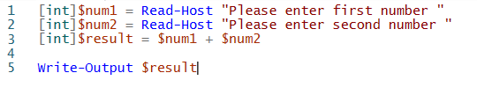
A:

Q: PowerShell list of all the windows events
A:

Q: PowerShell go over process and print the process name only
A:

Q: Open chrome and close it using PowerShell command.
A:

Q: PowerShell write shell function that check the user input string and check if its equal to the current string print welcome if not print sorry.
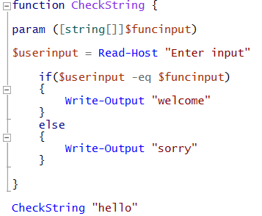
A:

Q: Bash script, read user name and check if its equal to the current user and print some message else print another message.
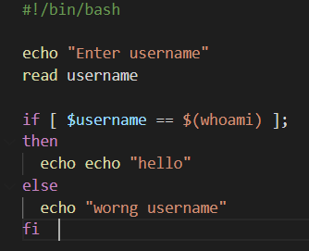
A:

Q: Linux create a directory under Home
A:

Q: Linux create file under the directory from step 14
A:

Q: Write something into this file from step 15
A:

Q: Is everything in Linux is file? true/false
A: True

Q: Is Linux case sensitive Operation system? True/false.
A: True

